Project Planning Phase
Project Planning Template (Product Backlog, Sprint Planning, Stories, Story points)
Date | 8 March 2026
Team ID | Team 199
Project Name | Insurance Fraud Detection Using Machine Learning
Maximum Marks | 8 Marks

Product Backlog, Sprint Schedule, and Estimation (4 Marks)
Use the below template to create product backlog and sprint schedule
Sprint | Functional  Requirement (Epic) | User Story  Number | User Story / Task | Story Points | Priority | Team  Members
Sprint-1 | Data Collection | USN-1 | As a developer, I collect insurance claim datasets for fraud detection | 3 | High | Mridul
Sprint-1 | Data Preprocessing | USN-2 | Clean and preprocess the dataset by removing missing and duplicate values. | 3 | High | Piyush
Sprint-2 | Feature Engineering | USN-3 | Select important features affecting insurance fraud prediction. | 2 | Medium | Kuldeep
Sprint-2 | Model Development | USN-4 | Train machine learning models (Logistic Regression, Decision Tree, Random Forest). | 4 | High | Mridul
Sprint-3 | Model Evaluation | USN-5 | Evaluate models using accuracy, precision, recall and F1-score. | 3 | High | Pallavi
Sprint-3 | Hyperparameter Tuning | USN-6 | Improve model performance using hyperparameter tuning. | 2 | Medium | Piyush
Sprint-4 | Result Visualization | USN-7 | Create charts and confusion matrix for model performance. | 2 | Medium | Pallavi
Sprint-4 | Documentation & Report | USN-8 | Prepare final project report and presentation. | 3 | High | Kuldeep

Project Tracker, Velocity & Burndown Chart: (4 Marks)
Sprint | Total Story  Points | Duration | Sprint Start Date | Sprint End Date  (Planned) | Story Points  Completed (as on Planned End Date) | Sprint Release Date  (Actual)
Sprint-1 | 10 | 7 Days | 02 Feb 2026 | 09 Feb 2026 | 10 | 09 Feb 2026
Sprint-2 | 10 | 7 Days | 10 Feb 2026 | 17 Feb 2026 | 10 | 17 Feb 2026
Sprint-3 | 10 | 7 Days | 18 Feb 2026 | 25 Feb 2026 | 10 | 25 Feb 2026
Sprint-4 | 10 | 7 Days | 26 Feb 2026 | 08 Mar 2026 | 10 | 08 Mar 2026

Velocity:
Imagine we have a 10-day sprint duration, and the velocity of the team is 20 (points per sprint). Let’s calculate the team’s average velocity (AV) per iteration unit (story points per day)

Story Points 10
AV= = = 1.42
Sprint Duration 7

* What this chart shows 📊
- Ideal Progress Line: Shows how work should decrease evenly from 40 story points (2 Feb 2026) to 0 (8 Mar 2026).
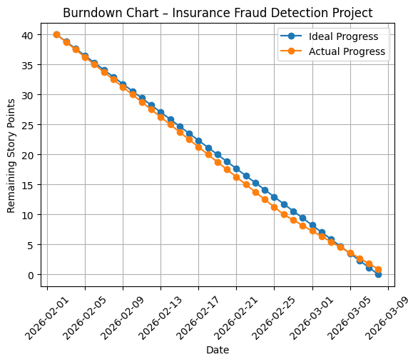
- Actual Progress Line: Shows the real progress based on your sprint plan:
  - Sprint-1 → 10 points completed
  - Sprint-2 → 10 points completed
  - Sprint-3 → 10 points completed
  - Sprint-4 → 10 points completed

Burndown Chart:
The burndown chart represents the remaining work in the project over time. The project started with 40 total story points on 2 February 2026. The ideal line shows the expected linear progress if the team completed work at a constant rate. The actual progress line represents the real work completed during each sprint. By 8 March 2026, all story points were completed, indicating that the project was successfully finished within the planned schedule.
https://www.visual-paradigm.com/scrum/scrum-burndown-chart/
https://www.atlassian.com/agile/tutorials/burndown-charts
Reference:
https://www.atlassian.com/agile/project-management
https://www.atlassian.com/agile/tutorials/how-to-do-scrum-with-jira-software
https://www.atlassian.com/agile/tutorials/epics
https://www.atlassian.com/agile/tutorials/sprints
https://www.atlassian.com/agile/project-management/estimation
https://www.atlassian.com/agile/tutorials/burndown-charts

